4CS001
Introductory Programming
&
Problem-Solving

Lab Report

Name: Sagar Mishra
Group: 4
Student ID: np02cs4a250038

Module Leader Tutor
_______________ ______________
Table of Contents
Lab | Lab Title | Page No. | Tutor’s Signature
8 | 1. Part 1 5  1.1 What is an exception in Python? 5  1.2 What is the purpose of using exception handling in Python? 5  1.3 What is the difference between a syntax error and an exception in Python? 5  1.4 How do you raise an exception in Python? 6  1.5 What is the try-except block in Python? 6  1.6 What is the syntax of the try-except block in Python? 6  2. Part 2 7  2.1 Write a Python program that prompts the user to enter two integers and then divides the first integer by the second integer. Handle any exceptions that may occur during the division operation. 7  2.2 Write a Python program that reads a file name from the user and attempts to open the file. Handle any exceptions that may occur if the file does not exist or if there is an error reading the file. 8  2.3 Write a Python program that prompts the user to enter a list of numbers and calculates the average of those numbers. Handle any exceptions that may occur if the user enters non-numeric values. 9  2.4 Write a Python program that generates a random number between 1 and 10 and prompts the user to guess the number. Handle any exceptions that may occur if the user enters non-numeric values or if the guess is out of range. 10  2.5 Write a Python program that prompts the user to enter a list of integers and then calculates the sum of those integers. Handle any exceptions that may occur if the user enters non-numeric values. 11  2.6 Using try…except, showcase the ZeroDivisionError. 11  2.7 Create a simple list containing five elements and try to print the sixth element of the list. [use IndexError exception] 12  2.8 Try printing a variable without declaring it. [use NameError exception] 12  2.9 The ‘else’ in try…except…else statements is used to run the code on the else block if there are no exceptions in the ‘except’ block. Show an example. 13  2.10 In Python, we can choose to throw an exception if a condition occurs. To throw an exception, we use the ‘raise’ keyword. Show an example. 13  3. Part 3 14  3.1 Write a Python program that prompts the user to enter a string and then converts it to an integer. Handle the ValueError exception that may occur if the string cannot be converted to an integer. 14  3.2 Ask the user for the numerator and denominator value; and perform division. If the user enters a number, the program will evaluate and produce the result. 15  If the user enters a non-numeric value, then, the try block will throw a ValueError exception, and we can catch that using a first catch block ‘except ValueError’ by printing the message ‘Entered value is wrong’. 15  And suppose the user enters the denominator as zero. In that case, the try block will throw a ZeroDivisionError, and we can catch that using a second catch block by printing the message ‘Can’t divide by zero’. 15  3.3 Ask the user to enter an amount of money. In the try block, run a condition to check if the input value is less than 10 thousand; in which case raise a ValueError and print your message inside it. In the except block, catch the ValueError we previously raised and print the message inside it. 16  3.4 Write a Python function that takes a list of integers as an argument and returns the largest integer in the list. Handle the ValueError that may occur if the argument is an empty list. 16  3.5 Write a Python function that takes a dictionary as an argument and returns the value associated with a given key. Handle the KeyError that may occur if the key does not exist in the dictionary. 17  3.6 Write a Python function that takes two strings as arguments and concatenates them. Handle the TypeError that may occur if either argument is not a string. 18  4. Part 4 19  4.1 You are working on a program that keeps track of the grades for a class of students. The program should allow the user to input the name and grades of each student and then calculate and display the average grade for the class. 19  Write a Python program that: 19  ▪ Uses a list to store the names of the students. 19  ▪ Uses a dictionary to store the grades of each student, with the student names as keys and the grades as values. 19  ▪ Uses exception handling to handle errors that may occur when the user inputs the grades, such as non-numeric values or values outside the range of 0-100. 19  Here are some additional details and requirements: 19  ▪ The program should prompt the user to enter the number of students in the class. 19  ▪ For each student, the program should prompt the user to enter the student's name and their grades (separated by commas). 19  ▪ The program should display an error message if the user enters an invalid grade for a student and allow the user to re-enter the grade. 19  ▪ The program should use a try-except block to handle exceptions when converting the grade to a float. 19  ▪ The program should use a while loop to allow the user to re-enter an invalid grade. 19

Name / Sign of Module Leader Name / Sign of Module Leader

_________________ ___________________
Date: Date:

Part 1

What is an exception in Python?

- In Python, exception is an event that occurs during the execution of a program that disrupts the normal flow of instructions. Exceptions are raised when an error is detected, such as invalid input, division by zero, or accessing a non-existent file, and they signal that the program cannot proceed as intended without special handling.
x = 10 / 0
This statement raises a ZeroDivisionError exception because division by zero is not allowed.

What is the purpose of using exception handling in Python?

- Exception handling in Python is used to handle runtime errors in a controlled way so that the program does not crash unexpectedly. It allows the program to detect errors, respond it appropriately, and continue execution or terminate safely with meaningful messages, thereby improving reliability and stability.

What is the difference between a syntax error and an exception in Python?

- A syntax error occurs when the Python code violates the language’s grammatical rules and is detected before the program runs, such as missing a colon or incorrect indentation. An exception, on the other hand, occurs during program execution when a logically valid statement causes an error, such as dividing by zero or accessing an invalid index. Syntax errors must be fixed before the program can run, whereas exceptions can be handled during runtime using exception handling mechanisms.

How do you raise an exception in Python?

- In Python, an exception is raised using the raise keyword. It can be used to trigger a built-in exception or a custom exception when a specific error condition occurs in the program. For example, raise ValueError("Invalid input") raises a ValueError with a custom error message.
age = -5
if age < 0:
raise ValueError("Age cannot be negative")

What is the try-except block in Python?

- The try–except block in Python is used to handle exceptions by placing code that may cause an error inside the try block and specifying how to handle that error in the except block. If an exception occurs in the try block, normal execution stops and control is transferred to the except block, preventing the program from crashing.
try:
result = 10 / 0
except ZeroDivisionError:
print("Division by zero is not allowed")

What is the syntax of the try-except block in Python?

try:
# code that may cause an exception
except ExceptionType:
# code to handle the exception

Part 2
- Write a Python program that prompts the user to enter two integers and then divides the first integer by the second integer. Handle any exceptions that may occur during the division operation.

- Code:
try:
num1 = int(input("Enter the first integer: "))
num2 = int(input("Enter the second integer: "))

result = num1 / num2
except ValueError:
print("Invalid input! Please enter integers only.")
except ZeroDivisionError:
print("Error! Division by zero is not allowed.")
else:
print(f"The result of {num1} divided by {num2} is {result}")
finally:
print("Program execution completed.")

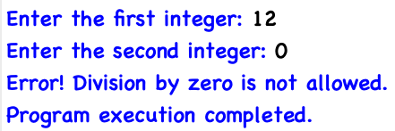

- Write a Python program that reads a file name from the user and attempts to open the file. Handle any exceptions that may occur if the file does not exist or if there is an error reading the file.

- Code:
file_name = input("Enter the file name: ")
try:
with open(file_name, 'r') as file:
content = file.read()
print("File content:\n")
print(content)
except FileNotFoundError:
print(f"Error: The file '{file_name}' does not exist.")
except IOError:
print(f"Error: Could not read the file '{file_name}'.")
finally:
print("File operation completed.")

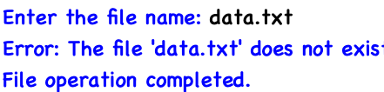

- Write a Python program that prompts the user to enter a list of numbers and calculates the average of those numbers. Handle any exceptions that may occur if the user enters non-numeric values.

- Code:
try:
numbers_input = input("Enter numbers separated by spaces: ")
numbers = [float(num) for num in numbers_input.split()]
if len(numbers) == 0:
raise ValueError("No numbers entered.")
average = sum(numbers) / len(numbers)
except ValueError as e:
print(f"Invalid input! {e}")
else:
print(f"The average of the entered numbers is: {average}")

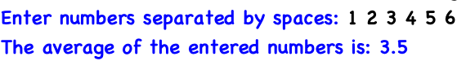

- Write a Python program that generates a random number between 1 and 10 and prompts the user to guess the number. Handle any exceptions that may occur if the user enters non-numeric values or if the guess is out of range.

- Code:
import random

secret_number = random.randint(1, 10)

try:
guess = int(input("Guess a number between 1 and 10: "))
if guess < 1 or guess > 10:
raise ValueError("Guess is out of range. Please enter a number between 1 and 10.")
if guess == secret_number:
print("Congratulations! You guessed the correct number.")
else:
print(f"Sorry! The correct number was {secret_number}.")
except ValueError as ve:
print(f"Invalid input! {ve}")



- Write a Python program that prompts the user to enter a list of integers and then calculates the sum of those integers. Handle any exceptions that may occur if the user enters non-numeric values.

- Code:
try:
numbers_input = input("Enter integers separated by spaces: ")
numbers = [int(num) for num in numbers_input.split()]
total = sum(numbers)
except ValueError:
print("Invalid input! Please enter integers only.")
else:
print(f"The sum of the entered integers is: {total}")

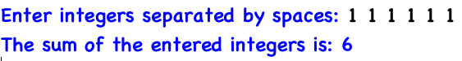

- Using try…except, showcase the ZeroDivisionError.

- Code:
try:
result = 10 / 0
except ZeroDivisionError:
print("Error: Division by zero is not allowed.")
else:
print(f"The result is {result}")

- Create a simple list containing five elements and try to print the sixth element of the list. [use IndexError exception]

- Code:
my_list = [10, 20, 30, 40, 50]

try:
print(my_list[5])
except IndexError:
print("Error: The element you are trying to access does not exist in the list.")

- Try printing a variable without declaring it. [use NameError exception]

- Code:
try:
print(my_variable)
except NameError:
print("Error: The variable is not defined.")

- The ‘else’ in try…except…else statements is used to run the code on the else block if there are no exceptions in the ‘except’ block. Show an example.

- Code:
try:
num1 = int(input("Enter the first number: "))
num2 = int(input("Enter the second number: "))
result = num1 / num2
except ZeroDivisionError:
print("Error: Division by zero is not allowed.")
except ValueError:
print("Error: Please enter valid integers.")
else:
print(f"The result of {num1} divided by {num2} is {result}")

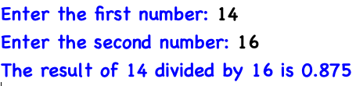

- In Python, we can choose to throw an exception if a condition occurs. To throw an exception, we use the ‘raise’ keyword. Show an example.

- Code:
age = int(input("Enter your age: "))
if age < 0:
raise ValueError("Age cannot be negative")

print(f"Your age is {age}")

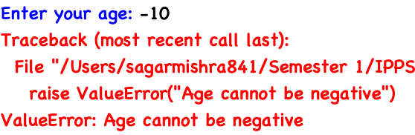

Part 3
- Write a Python program that prompts the user to enter a string and then converts it to an integer. Handle the ValueError exception that may occur if the string cannot be converted to an integer.

- Code:
try:
user_input = input("Enter a number: ")
number = int(user_input)
except ValueError:
print("Error: You must enter a valid integer.")
else:
print(f"The integer value is: {number}")

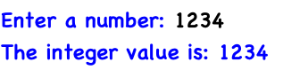

- Ask the user for the numerator and denominator value; and perform division. If the user enters a number, the program will evaluate and produce the result.

If the user enters a non-numeric value, then, the try block will throw a ValueError exception, and we can catch that using a first catch block ‘except ValueError’ by printing the message ‘Entered value is wrong’.

And suppose the user enters the denominator as zero. In that case, the try block will throw a ZeroDivisionError, and we can catch that using a second catch block by printing the message ‘Can’t divide by zero’.

- Code:
try:
numerator = int(input("Enter the numerator: "))
denominator = int(input("Enter the denominator: "))
result = numerator / denominator
except ValueError:
print("Entered value is wrong")
except ZeroDivisionError:
print("Can't divide by zero")
else:
print(f"The result of {numerator} divided by
{denominator} is {result}")

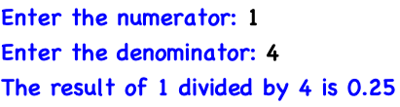

- Ask the user to enter an amount of money. In the try block, run a condition to check if the input value is less than 10 thousand; in which case raise a ValueError and print your message inside it. In the except block, catch the ValueError we previously raised and print the message inside it.

- Code:
try:
amount = float(input("Enter the amount of money: "))
if amount < 10000:
raise ValueError("Amount must be at least 10,000")
except ValueError as ve:
print(f"Error: {ve}")
else:
print(f"You entered a valid amount: {amount}")
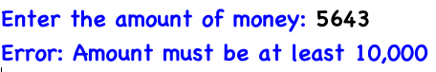
- Write a Python function that takes a list of integers as an argument and returns the largest integer in the list. Handle the ValueError that may occur if the argument is an empty list.
- Code:
def find_largest(numbers):
try:
if len(numbers) == 0:
raise ValueError("The list is empty.")
largest = max(numbers)
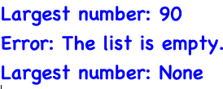
except ValueError as ve:
print(f"Error: {ve}")
return None
else:
return largest

nums = [10, 25, 7, 90, 42]
print("Largest number:", find_largest(nums))]

empty_list = []
print("Largest number:", find_largest(empty_list))

- Write a Python function that takes a dictionary as an argument and returns the value associated with a given key. Handle the KeyError that may occur if the key does not exist in the dictionary.

- Code:
def get_value(my_dict, key):
try:
value = my_dict[key]
except KeyError:
print(f"Error: The key '{key}' does not exist in the dictionary.")
return None
else:
return value

sample_dict = {"name": "Alice", "age": 25, "city": "New York"}

print("Value:", get_value(sample_dict, "age"))
print("Value:", get_value(sample_dict, "country"))

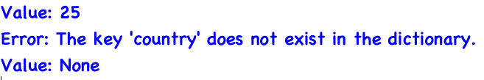

- Write a Python function that takes two strings as arguments and concatenates them. Handle the TypeError that may occur if either argument is not a string.

- Code:

def concatenate_strings(str1, str2):
try:
if not isinstance(str1, str) or not isinstance(str2, str):
raise TypeError("Both arguments must be strings.")
result = str1 + str2
except TypeError as te:
print(f"Error: {te}")
return None
else:
return result

print(concatenate_strings("Hello, ", "World!"))
print(concatenate_strings("Hello, ", 123))

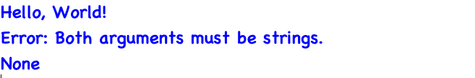

Part 4
- You are working on a program that keeps track of the grades for a class of students. The program should allow the user to input the name and grades of each student and then calculate and display the average grade for the class.

Write a Python program that:
- Uses a list to store the names of the students.
- Uses a dictionary to store the grades of each student, with the student names as keys and the grades as values.
- Uses exception handling to handle errors that may occur when the user inputs the grades, such as non-numeric values or values outside the range of 0-100.

Here are some additional details and requirements:
- The program should prompt the user to enter the number of students in the class.
- For each student, the program should prompt the user to enter the student's name and their grades (separated by commas).
- The program should display an error message if the user enters an invalid grade for a student and allow the user to re-enter the grade.
- The program should use a try-except block to handle exceptions when converting the grade to a float.
- The program should use a while loop to allow the user to re-enter an invalid grade.

- Code:
P.T.O

students = []
grades_dict = {}

while True:
try:
num_students = int(input("Enter number of students: "))
if num_students <= 0:
print("Number of students must be greater than 0.")
else:
break
except ValueError:
print("Please enter a valid integer.")

# Input student details
for i in range(num_students):
name = input(f"\nEnter name of student {i + 1}: ")
students.append(name)

while True:
grade_input = input(f"Enter grades for {name} (separated by commas): ")
grade_list = grade_input.split(",")

valid_grades = []
try:
for grade in grade_list:
grade = float(grade.strip())

if grade < 0 or grade > 100:
raise ValueError("Grade out of range")

valid_grades.append(grade)

grades_dict[name] = valid_grades
break

except ValueError:
print("Invalid grade detected! Please enter numbers between 0 and 100.")

total_sum = 0
total_count = 0

for grade_values in grades_dict.values():
total_sum += sum(grade_values)
total_count += len(grade_values)

class_average = total_sum / total_count
print("\nStudent Grades:")
for student in students:
print(f"{student}: {grades_dict[student]}")

print(f"\nClass Average Grade: {class_average:.2f}")
